
City of Moreno Valley
Community Development Department
Planning Division
City Hall Council Chamber
14177 Frederick Street
Moreno Valley, CA 92553

NOTICE OF PUBLIC HEARING (VIA TELECONFERENCE ONLY)
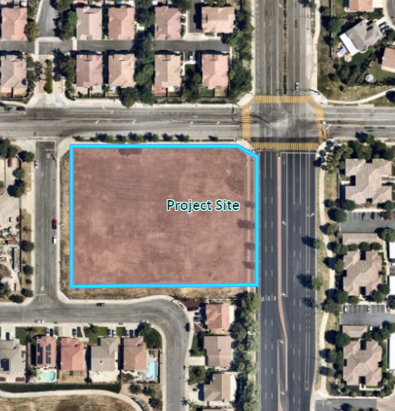
PURSUANT TO COVID-19 GOVERNOR EXECUTIVE ORDER N-29-20
Notice of Teleconferenced Public Hearing before the Planning Commission of the City of Moreno Valley:
DATE & TIME: June 11, 2020 at 7:00 P.M. VIA TELECONFERENCE ONLY
COVID-19 TELECONFERENCE INSTRUCTIONS:
For Teleconference Meeting public participation instructions, please see agenda at http://morenovalleyca.iqm2.com/Citizens/default.aspx
Via Entrada
John F. Kennedy Drive
PROJECT LOCATION: Southwest corner of Moreno Beach Drive and John F. Kennedy Drive (APN: 304-240-004), District 4.
CASE NUMBER(s): PEN19-0154
CASE PLANNER: Jeff Bradshaw, Associate Planner (951) 413-3224 or jeffreyb@moval.org
Moreno Beach Drive
<APN>
<Property Owner>
<Street Address>
<City, State, Zip>
NOTICE OF PUBLIC HEARING
PROPOSAL: Plot Plan for a 19,324 square foot retail center on a 2.45-acre parcel. Retail center to include a 13,524 square foot market and a 5,800 square foot retail building for restaurant and office uses.

ENVIRONMENTAL DETERMINATION: The project has been evaluated against criteria set forth in the California Environmental Quality Act (CEQA) Guidelines and it was determined that the project is exempt from the provisions of CEQA as a Class 32 Categorical Exemption in accordance with CEQA Guidelines Section 15332 for In-fill Development Projects.
PUBLIC HEARING: All interested parties will be provided an opportunity to submit oral testimony during the teleconferenced Public Hearing and/or provide written testimony during or prior to the teleconferenced Public Hearing. The application file and related environmental documents may be inspected by appointment at the Community Development Department at 14177 Frederick Street, Moreno Valley, California by calling (951) 413-3206 during normal business hours (7:30 a.m. to 5:30 p.m., Monday through Thursday).
COVID-19 – IMPORTANT NOTICES: Please note that due the COVID-19 pandemic situation, staff will attempt to make reasonable arrangements to ensure accessibility to inspect the aforementioned records. In addition, special instructions on how to effectively participate in the teleconferenced Public Hearing, as approved by Governor Executive Order N-25-20, will be posted at http://morenovalleyca.iqm2.com/Citizens/default.aspx and will be described in the Planning Commission agenda.
PLEASE NOTE: The Planning Commission may consider and approve changes to the proposed items under consideration during the teleconferenced Public Hearing.
GOVERNMENT CODE § 65009 NOTICE: If you challenge any of the proposed actions taken by the Planning Commission in court, you may be limited to raising only those issues you or someone else raised during the teleconferenced Public Hearing described in this notice, or in written correspondence delivered to the Planning Division of the City of Moreno Valley during or prior to, the teleconferenced Public Hearing.

